Coen et al Chapter 3 draft

ABSTRACT

Roads networks may have profound impacts on the viability of wildlife populations. Highways can be barriers to wildlife movement, leading to genetic diversity loss, inbreeding, and increased extinction risk for small, isolated populations on either side. Differences in highway characteristics, particularly environmental disturbances tied to higher traffic rates, can increase wildlife avoidance of highways. The effects that highways have on wildlife movement can be variable, dependent on the unique disturbance tolerance of individual species. In this study, we examined genetic connectivity relative to traffic rates in coyote populations adjacent to highways with different usage intensities. Additionally, we examine the impact of disturbance tolerance on genetic connectivity across a highway for coyotes and gray fox. We collected canid scat samples for genetic analysis from opposite sides of I-580 and I-680 in the East Bay and I-80, US 50, SR 49 and SR 20 in the Sierra Nevada foothills. East Bay highways have high traffic rates (115,000-260,000 annual average daily traffic) while the Sierra Nevada foothill highways range from high to lower traffic rates (3,000-258,000 annual average daily traffic). Genetic diversity was high in all examined populations. We found little evidence of contemporary genetic structure across focal highways for either species, suggesting that these highways may be permeable to dispersal. All genetic differentiation that we observed was driven by family structure within sampled populations. Signals of decreased dispersal may take longer to manifest in large, genetically diverse populations. Increased usage on highways in the study regions have only recently increased. As human populations in the focal areas are projected to increase, along with associated intensification of traffic rates, maintaining genetic connectivity across highways for species will become increasingly important.

INTRODUCTION

While facilitating connectivity for human activities, road networks have the potential to reduce connectivity of wildlife populations and negatively impact their viability. Habitat loss through direct conversion into road or the alteration of abiotic conditions of the landscape adjacent to a roadway can negatively impact habitat use. Reductions in dispersal through direct mortality or avoidance of roadway environments may serve to further disrupt gene flow between population fragments (Jaeger et al. 2005, Coffin 2007, Taylor and Goldingay 2010). Demographic stochasticity, genetic diversity loss, and inbreeding depression are intensified in isolated population fragments, increasing the risk of local extinction (Lande 1988, Frankham 1996, Epps et al. 2005, Holderegger and Di Giulio 2010).

Overpasses or undercrossings may be installed to restore natural gene flow patterns. However, to effectively plan these and other mitigation activities, transportation agencies must know which roads to target, whether existing structures are providing wildlife passage, and which species are most affected. The impacts of roads on wildlife connectivity cannot be generalized in space, between taxa, or among species within the same taxa, complicating mitigation planning. Physical characteristics of roads (e.g. width, gradient, and traffic volume) can affect their permeability to different species (Marsh et al. 2005, Charry and Jones 2009). Traffic volume in particular has been shown to be an important determinant of wildlife response to roads (Jaeger et al. 2005). In highways through the Canadian Rocky Mountains, including the Trans-Canada Highway, sections of low to moderate traffic were more permeable to carnivore passage than sections of high traffic (Alexander et al. 2005). Annual average daily traffic volumes (AADT) as low as 10,000 can create nearly complete barriers to wildlife movements (Charry and Jones 2009).

The degree to which wildlife will move across roads depends upon species-specific dispersal behaviors and life history characteristics. Some taxa, such as reptiles, amphibians, and mid- to large sized mammals, are particularly impacted by roads (Fahrig and Rytwinski 2009, Benítez-López et al. 2010). Even within sensitive species there are differences in behavioral responses to roads. Disturbance tolerance is thought to be one characteristic that determines a species’ sensitivity to roads. For example, the Trans-Canada Highway acts as a barrier for grizzly bear (*Ursus arctos*) but not for black bear (*Ursus americanus*) movement, likely because grizzly bears tend to avoid human activity and therefore approach roads less often (Sawaya et al. 2014). Perception of risks not tied directly to human activities can influence behavior for organisms faced with crossing a road surface. For example, smaller snake species more vulnerable to avian predation were more likely to avoid open habitat created by roads than larger snakes (Andrews and Gibbons 2016).

Within California, highways have been documented as significant barriers to gene flow for numerous taxa (Riley et al. 2006, Delaney et al. 2010, Riley et al. 2014a). These studies have focused on the Southern California region, which hosts highly urbanized counties with heavily trafficked highway networks. Few studies have investigated whether highways in Northern California, where urban centers are more discrete, have a similar impact on wildlife gene flow. Urbanization approaches levels observed in Southern California primarily in the greater Bay Area and Sacramento regions.

The ability to maintain population connectivity across California highways is related to a species’ willingness to utilize edge habitats, such as those alongside roadways. Habitat generalists, like coyotes (*Canis latrans*) and deer (*Odocoileus* spp) may be less affected by roads than habitat specialists, such as gray foxes (*Urocyon cinereoargenteus*), which in California tend to be tied to large patches of mid-elevation scrub-lands (Fedriani et al. 2000, Farias et al. 2005, Sacks et al. 2005, 2008, Kowalski et al. 2015). We examined the genetic diversity present in populations of coyote alongside major highways in the East Bay and Sierra Nevada foothill regions, and gray fox populations adjacent to two highways in the Sierra Nevada foothills to examine how highways affect genetic connectivity. These two species have been documented inhabiting urban settings and have similar reproductive phenology, dispersal timing, territoriality, and diet, differing mainly in the degree of habitat specialization. Additionally, both species are abundant and leave conspicuous scats that can be collected for genetic analysis. In this study, we predicted that 1) highways are a barrier to gene flow for both species 2) traffic rates are correlated with increased disruption in genetic connectivity, and 3) genetic connectivity across highways will be more negatively impacted in gray fox than in coyote. With dramatic increases in human populations projected in the next few decades for these Northern California study regions, determining whether highways are currently disrupting genetic connectivity will become increasingly important.

METHODS

Study Highways and Regions

We studied coyotes separated by Interstates 680 (I-680) and 580 (I-580) in the inland valleys of the East Bay region of the Bay area, and Interstate 80 (I-80) and U.S Route 50 (US 50) in the lower Sierra Nevada foothills (Figure 1). These are 6-10 lane highways, with central median barriers, and are heavily trafficked. East Bay highways were travelled by >180,000 vehicles daily within a heavily populated urban and suburban matrix. The Sierra Nevada foothills traffic volumes ranged from >140,000 vehicles/day in the southern section to 65,000 vehicles/day in the northern, more rural region of our study area (Caltrans 2015). The southern portion of the study area is comprised of urban matrix surrounding Sacramento with human population densities decreasing as the highways travel east and north from the city.

Additionally, we studied both coyote and gray fox populations separated by State Route 49 (SR 49) and 20 (SR 20) between the cities of Auburn and Grass Valley in the Sierra Nevada Foothills (Figure 1). These are 2 lane, undivided highways, traveled by 2000-40,000 vehicles daily (Caltrans 2015). The landscape flanking these state routes were comprised of a mixture of urban, suburban, suburban-rural, and rural land. Urban centers are concentrated around the cities of Auburn, Grass Valley and Nevada City. The density of human habitation decreases with distance from the city centers. Rural land use ranges from agriculture (vineyards and grazing), to commercial timber and managed forest operated by land trusts and the US Forest Service.

Although both the East Bay and Sacramento region are highly developed, gray fox and coyotes have been shown to inhabit urban and suburban habitats and therefore development alone is not likely to act as a barrier to dispersal (Atkinson and Shackleton 1991, Harrison 1997, Grinder and Krausman 2001, Crooks 2002, Rountree 2004, RILEY 2006, Grubbs and Krausman 2009). Therefore, the highways are the only major human generated landscape feature likely to disrupt gene flow. In addition to the presence of the study highways in the Sierra Nevada foothills, the American River mainstem and the North Fork American River run through the center of the study region and may serve as dispersal barriers.

Molecular Methods

Sample collection and DNA Extraction

Sampling was conducted in open space and parkland in regions within 10 km adjacent to the study highways or along road transects within 13 km of the SR 20 and SR 49. We collected mesopredator fecal samples (scat) along road transects in the study area from November 2014 to August 2015 and February to November 2016. A fraction of each scat was preserved in 95% ethanol in the field for later DNA extraction. In addition, we obtained tissue samples from road-killed coyote and gray fox observed along road transects. GPS points recorded the exact location where each sample was collected. Fecal samples were stored at 4 ⁰C upon return to the lab. DNA was extracted using the QIAamp Mini Stool Kit (QIAGEN). To minimize opportunities for contamination, all extractions were done in a laboratory isolated from post-PCR products and lab benchtops were bleached before and after fecal samples were handled.

Species Identification and Genotyping

Samples were identified to the species level by sequencing a portion of the cytochrome b gene. Cytochrome b is a region of mitochondrial DNA commonly used to distinguish between mammal species. All samples identified as non-target species (e.g. bobcat, skunk) were archived for future study. Samples confirmed to have originated from coyote were genotyped using 13 microsatellite loci optimized for use with coyote fecal DNA: AHT137, AHT142, AHTh171, CPH11, CPH18, CXX279, CXX374, CXX468, CXX602, INU055, REN54P11, REN162C04, and REN169O18 (Quinn & Sacks 2014). Those samples identified as originating from gray fox were genotyped using 13 microsatellite loci optimized for use with gray fox fecal DNA: AHT142, AHTh171, CPH18, CPH8, FH2004, FH2010, FH2088, INU055, REN105L03, REN162C04, REN54P11, RF2001Fam, and RFCPH2 (Moore et al. 2010). Microsatellite loci were multiplexed using the QIAGEN Multiplex PCR Kit (QIAGEN) with two multiplexes containing 7 loci each. Two microliters of PCR product were combined with 9.5 μl of highly deionized formamide and 0.5 μl of Genescan 500 LIZ size standard (Thermo Fisher Scientific; Thermo). Fragment analysis was performed on an ABI PRISM 3730 DNA Analyzer (Thermo) and alleles were scored with STRand software (Toonen and Hughes 2001). Negative controls were included with each PCR to detect contamination. Samples were genotyped three times at each locus to detect and correct for allelic dropout and other genotyping errors commonly encountered when working with degraded samples (WAITS and PAETKAU 2005). Only samples with >85% complete genotypes were used for genetic analysis. The R package Allelematch (Galpern et al. 2012) was used with these samples to identify unique genotypes and remove duplicates.

Data Analysis

Before any analyses were conducted, microsatellite loci were tested for conformance to Hardy-Weinberg equilibrium and linkage equilibrium using GenAlEx version 6.502 (Peakall and Smouse 2006, 2012) using sequential Holms-Bonferroni corrections to account for multiple comparisons (Rice 1989). We used side of focal highway as locations for samples collected for these and later analyses. We then examined genetic diversity within and among canid populations in our study areas by calculating the number of alleles, allelic richness, expected and observed heterozygosity (He, Ho) in GenAlEx. Because small sample sizes can negatively bias genetic diversity estimates, we did a rarefaction analysis in HP-Rare (Kalinowski 2005) to develop estimates of allelic richness corrected for unequal sample sizes. Additionally, we measured pairwise relatedness (r) among coyotes within and among sampling locations in GenAlEx to identify close relatives (first and second order) in our dataset.

We used STRUCTURE version 2.3.4 (Pritchard et al. 2000) to examine how genetic diversity was partitioned across our sampling locations. STRUCTURE, a Bayesian clustering algorithm, inferred the most likely number of populations of coyote and gray fox in the study areas. Since our sampling was conducted on a relatively fine scale for wide-ranging species, we expected population structuring to be weak, even if the focal highways were significant barriers to gene flow. Therefore, we used the Hubisz et al. (2009) LOCPRIOR model that improves STRUCTURE’s ability to detect weak population structure by using geographic sampling location as a prior. We used the population admixture model with correlated allele frequencies. Each run consisted of 100,000 Markov chain Monte Carlo iterations following a burn-in period of 1,000,000 iterations. We tested the likelihood of K=1 through K=5 for the East Bay and K=1 through K=6 for the Sierra Nevada foothills datasets, where K is the true number of populations. Ten replicates were conducted for each K. We determined K by examining plots of the mean likelihood value ln Pr(X|K) and calculating ∆K (Evanno et al. 2005) in STRUCTURE HARVESTER (Earl and vonHoldt 2011). The program CLUMPAK (Kopelman et al. 2015) was used to compile individual assignments across replicates and we used custom R code implemented in the ggplot2 package to create bar plots to visualize results (Wickham 2016).

We examined population genetic structure by estimating pairwise FST values (a measure of genetic differentiation) among sampling locations in an AMOVA framework in GenAlEx. Significance of pairwise FST values was determined through 9,999 permutations. We calculated Nei’s genetic distance (Nei 1978, Distance et al. 2016) among sampling locations in GenAlEx. Nei’s genetic distance matrix was paired with a geographic distance matrix to test for isolation by distance (IBD), which occurs when genetic distance between sampling locations increases with geographic distance. Geographical distance was calculated as the Euclidean distance between locations where pairs of individuals were sampled, recorded as GPS points (decimal latitude and longitude). For individuals that were detected twice, we used two averaged locations to represent their detection center. The relationship between genetic and geographic distance in our study areas was assessed with Mantel tests in the R package VEGAN (Dixon 2003).

To determine whether the study highways or traffic rates have a significant effect on genetic distance between sampling locations, we measured the resistance distance between sampling locations using CIRCUITSCAPE v4.0.5 (McRae 2006). For highways alone as a barrier, all highway cells were coded as high resistance with all other landscape cells treated as low resistance. To create a resistance surface based on traffic rates, sections of highway were binned into ten different traffic intensities based on Caltrans Annual Average Daily Traffic (AADT) counts from below 10,000 to over 202,000 (Caltrans gis source). Highway cells within each section were then coded based on which traffic rate bin they fell within. Connectivity between two points are assessed along all possible pathways based on an eight-neighbor connection method to generate an average resistance between points. Support for each resistance surface was then evaluated by fitting linear mixed-effects models using the maximum-likelihood population effects (MLPE) parameterization in the R package ResistanceGA to account for the nonindependence of values within pairwise distance matrices (Clarke et al. 2002, Van Strien et al. 2012, Peterman et al. 2014, Peterman 2018).

RESULTS

Sample collection and species identification

We collected a total of 251 and 327 mesopredator scats from our hiking and road transects respectively. The species identification test revealed that 190 of these samples originated from coyote and 213 of these samples were from gray fox. We were able to obtain high quality genotypes (data at >85% of loci) for 102 coyote and 90 gray fox (Table 1). Of these, 97 and 60 were unique coyote and gray fox genotypes, respectively. Coyote samples were distributed equally on either side of study highways SR 49, I-80, and I-680. For I-580 in the East Bay region, samples were largely located north of the highway, while in the Sierra Nevada foothills region, few samples were located south of US 50, in both cases due to poor access for sampling. In gray fox, there were 37 samples on the east side of SR 49 and 20 samples on the west side of 49.

Genetic Diversity

For populations not containing close relatives (see below), no significant deviation from linkage equilibrium was observed at any loci after implementing the sequential Bonferroni correction (alpha = 0.0039). However, eight loci (AHT137, CXX374, CXX468, CPH11, CPH18, REN54P11, CXX279, and REN162C04) deviated significantly from Hardy Weinberg equilibrium in at least one population for coyote. In gray fox, eight loci (CHP8, RFCHP2, FH2088, FH2004, AHTh171, FH2010, CXX402 and RF2001) were significantly out of equilibrium. For both species this was likely due to family structure in our samples (see below).

All sampling regions showed high levels of genetic diversity. The total number of alleles observed for coyotes within sampling locations ranged from 54-99 (East Bay), 37-108 (Sierra Nevada foothills), 91 (East SR 49), and 75 (West SR 49). For gray fox, the number of alleles observed ranged from 96 (East SR 49) to 85 (West SR 49). When rarefaction was conducted, coyote allelic richness ranged from 3.5-3.9 in the East Bay and 2.8-4.8 in the Sierra Nevada foothills (Table 1). Gray fox showed a similar pattern, with an allelic richness of 7.29 for East SR 49 and 6.36 for West SR 49 sampling locations. Measures of Ho and He (estimates of gene diversity in a population) were high in all regions for both species. Coyote Ho ranged from 0.60-0.72 in the East Bay, 0.62-0.88 in the Sierra Nevada foothills, and 0.70-0.73 around SR 49 and 0.60 in gray fox on both sides of SR 49 (Table 1).

Mean pairwise relatedness values (r) within sampling locations for coyotes showed that most individuals were not closely related (0.08-0.09 in the East Bay, 0.03-0.24 in Sierra Nevada foothills). However, some first order relationships (parent-offspring, full siblings, r ~0.50) were detected within the East Bay, all from West I-680. Second order relationships (grandparent-grandchild, half-siblings, r~0.25) were also detected, primarily from West I-680 (18 pairs) and one pair from East I-680. Within the Sierra Nevada foothills region, first order relationships were detected for two pairs, one on each side of SR 49. Second order relationships were also detected for four pairs, one each from South SR-50 and South I-80-East SR 49, while the remaining two came from South I-80-North SR 50. In all cases, the pair of individuals exhibiting these family relationships were sampled along the same side of the highways.

For gray fox the mean pairwise relatedness value was 0.11 for both sides of the highway. East of SR 49, second order relationships were detected for 25 pairs, while the west of SR 49 contained 7 pairs of second order relatedness. First order relatedness scores were recorded for 5 pairs within the East SR 49 and 2 in the West SR 49. Additionally, one first order pair (r = 0.54) was sampled on opposite sides of the highway, 9 km apart, while all other pairs were sampled on the same side of the highway.

Genetic Connectivity

STRUCTURE revealed two genetic clusters in the East Bay (mean ln Pr(X|K) = -1226.13; Figure 2). One cluster consisted of 11 individuals from the West I-680 sampling location while the second cluster contained individuals from all three sampling locations. Relatedness within the West I-680 sampling locations was high with a mean relatedness score of 0.10 for individuals sampled. Examining relatedness by cluster showed that the cluster comprised of individuals from all three sampling locations had a mean relatedness score of 0.05. The other cluster with individuals only from West I-680 had a mean relatedness score of 0.12. These higher values were driven by the presence of multiple first order relatives.

Within the Sierra Nevada foothills, two and four genetic clusters were best supported (mean ln Pr(X|K) = -3295.63 and -2971.70). In both the K = 2 and K = 4 scenarios revealed by STRUCTURE, neither cluster was associated with side of highway and there was no clear pattern associated with cluster assignment and sampling location, suggesting that K = 1 is more likely (Figures 3, 5).

Within the gray fox samples, two genetic clusters were most likely, with eight individuals split into a separate subpopulation (K1) (Figure 4, 6). Individuals within K1 were found throughout the study area, including on opposite sides of SR 49 (Figure 6). When we examined relatedness within K1, however, we found that the average relatedness value was 0.20 compared with a value of 0.09 for the cluster containing the other 49 individuals. All individuals within the K1 cluster have a second order relationship with at least one other group member. Three of the pairs within the group are first order relationships (r = 0.58-0.62).

Pairwise FST values, estimating genetic differentiation between sampling locations relative to sides of the highway, were not significant for either species, with two exceptions for coyotes. In coyotes, FST within each region was low, with significant differentiation only seen across highway I-80 for populations sampled adjacent to SR 49 (Table 2). The pairwise FST between the gray fox for side of highway was zero (FST = 0, p = 0.425). When examined for the K1 and K2 clusters pairwise FST was 0.34 (P = 0.001) but this was largely driven by the number of close relatives in the K1 group.

Mantel tests revealed no association between genetic and geographic distance for gray fox or coyotes in the Sierra Nevada foothills (r = 0.03, p = 0.24; r = -0.02, p = 0.58, respectively), but there was a weak association observed in the East Bay (r = 0.16, p = 0.05). Neither highway presence or traffic rates seemed to influence genetic distance with the equally permeable landscape as the best supported resistance surface for gray fox and Sierra Nevada foothill coyotes. In the East Bay, the model that included resistance based on traffic rates for highway segments was the best supported for coyotes (Table 3).

DISCUSSION

Highways have the potential to disrupt connectivity of wildlife populations, acting as a partial or total dispersal barrier for even wide-ranging species. Populations fragmented by roads over time can exhibit genetic differentiation due to a lack of gene flow via dispersal (Riley et al. 2006, 2014b, Sawaya et al. 2014). Barrier permeability is tied to an organism’s perception of risk and tolerance for disturbance (Clevenger and Waltho 2005, Jaeger et al. 2005, Wright and Wright 2017). Highways present a landscape feature with many associated environmental disturbances, producing light, noise, and movement beyond the range typically encountered by organisms in a natural environment. Tolerance to high levels of disturbance can increase the connectivity of species across highway barriers. Those species that are disturbance averse or more sensitive to edge and open habitats are more at risk of experiencing disruptions in dispersal imposed by road networks. The aim of this study was to determine whether highways disrupt wildlife gene flow in the East Bay and the Sierra Nevada foothills, using coyote as a model species. Additionally, tolerance for disturbance was examined by comparing genetic connectivity within gray fox and coyote populations across SR 49.

We found that coyote and gray fox populations within the study regions were genetically diverse, with high heterozygosity and allelic richness for all sampling locations. These results are in line with other findings of canid genetic diversity throughout California (Sacks et al. 2008, Deyoung et al. 2009 Coen et al. 2015). High levels of genetic diversity suggest that both study regions support thriving populations of both species.

It is unlikely that any of the focal highways form a complete barrier to movement for either species. There was no genetic structuring for coyotes or gray foxes across SR 49. Even for the more heavily trafficked highways in the East Bay and Sacramento regions (AADT average >180,000 and >84,000, respectively), coyotes exhibited no evidence of genetic structuring relative to side of highway.

In the Sierra Nevada foothills study area, both STRUCTURE and pairwise FST analysis indicated presence of only a single coyote population. This result was unexpected because an extensive network of camera traps in the study area has not observed coyotes using crossing structures in the Sierra Nevada foothills study area (F. Shilling, unpublished data). However, camera traps have revealed that coyotes are using higher elevation crossing structures (northeast of our study area), (F. Shilling, unpublished data). These coyotes could be migrating into and reproducing in the study area. Additionally, the American River bike trail, which follows a riparian corridor along the Sacramento River from Folsom Lake into the city of Sacramento, may provide passage across I-80.

As coyotes showed no evidence of genetic structuring across large, highly trafficked highways, it was expected that this adaptable species would exhibit genetic connectivity across a smaller highway with a lower average traffic rate (AADT <20,300). In comparison, gray fox populations were expected to show evidence of disrupted genetic connectivity due to the presence of SR 49. Whereas coyotes have been shown to inhabit a wide range of human-modified habitats, including heavily urbanized cities, gray fox, tend to be more elusive, and less frequently observed in heavily modified human settings (Lombardi et al. 2017).

Interestingly, pairwise relatedness analyses showed that almost all detections of related individuals for gray fox were clustered on the same side of the highway. The same pattern was observed for coyote in the East Bay. Both species exhibit delayed dispersal of individuals from their natal habitat, where individuals stay with the parental pair and help with rearing siblings (). This behavior may increase the chance of sampling family groups. Additionally, Riley (2006) showed that younger dispersers hold the territories adjacent to highways, with these being smaller and denser than territories away from highways. This pile up of dispersers along highway edges may also contribute to increased relatedness observed in a single season. Direct dispersal was observed for gray fox across SR 49. One pair of first order relatives for gray fox, either siblings or parent-offspring, were detected across SR 49 from each other, however, separated by approximately nine kilometers. This likely represents a dispersal event by a juvenile male.

These results contrast with a study conducted in Southern California which found that the Ventura freeway was a significant barrier to gene flow in coyote (Riley et al. 2006). It is possible that the highly urban environment of Los Angeles imposes additional constraints on coyote movements that are not present in the regions of Northern California studied. In the Ventura freeway study, coyotes were able to cross the highway, but migrants could not breed successfully due to territorial conflicts (Riley et al. 2006). There is more habitat available in both study areas in comparison to the regions examined around Southern California. Sacramento hosts a chain of parks connected by a riparian corridor that further connects to several U.S. National Forests north of the highly urbanized city of Sacramento. The East Bay inland valleys are ringed by a network of land trusts and parks in the Diablo Range. In both regions, migrants may be able to acquire territory and reproduce which would reduce signals of population isolation.

Unexpectedly, gray fox samples were encountered more frequently than coyote in the SR 49 road transects. Contrary to our expectations, we found that gray fox were distributed throughout the entire study area, even in urban areas such as Auburn. Grays foxes tend to be most abundant in places where potential predators (coyotes, bobcats) are less abundant (Fedriani et al. 2000, Farias et al. 2005, Temple et al. 2010). Competitive exclusion by the presence of coyote has been linked to increased use of urban habitats in gray fox (Crooks and Soulé 1999, RILEY 2006). Prevalence of coyote within the urban centers along SR 49 may explain the lower detection rates of gray fox in these cities. Contrastingly, the high detection rates of gray fox in the suburban and suburban-rural matrix might be the due to the proportion of private lands (lower detection probability) and human wildlife conflict (Poessel et al. 2017) resulting in lower abundances of coyotes.

Anthropogenic change to the environment occurs often over short time scales. As an example, construction of Interstate 5 through California, a 2,222 km stretch of highway running the length of the state, was completed in 25 years. How these changes impact the health and stability of populations is of increasing importance, particularly in the face of increased anthropogenic landscape alteration. Unfortunately, genetic stability within a population after a disturbance is not immediate, requiring time for the population to reach a new equilibrium. This creates a disconnect between the event that can change the genetic composition of a population and the time until this change is able to be detected in what is referred to as a time lag (Epps and Keyghobadi 2015).

Several factors, both inherent to the focal species and the system, influence the length of a time lag. For example, the permeability of a barrier between bisected populations determines the rate of gene flow. Within a species, factors such as generation time, dispersal distances, population size and genetic variability of the population at the break of connectivity all play a role in time lags (Epps and Keyghobadi 2015). For small populations, those with short generation time, or those that have low initial genetic variation, time lags will be short and signals of disrupted gene flow will manifest quickly. For species like gray fox and coyote, which have large populations, high genetic variability, are capable of long-range dispersal, and have relatively long generation times, detection of a disruption in genetic connectivity may take many generations to manifest.

Our findings suggest that all focal highways in this study are not barriers to coyote gene flow and that SR 49 is a permeable barrier to dispersal for gray fox, although a time lag effect may be present. The intensity of use for these highways is more recent than their appearance on the landscape. Interstate 80, for example, was designated for construction in 1956. This highway was widened to its current six to eight lane width in Sacramento in 1973 and again in 2011 to accommodate increased traffic densities generated by growing populations in Sacramento (Faigin 2020). The more rural Sierra Nevada foothills have also experienced tremendous growth over the previous two decades, between 7-11% for various cities within Placer County’s foothill region (Center for Strategic Econimic Research 2014). Following the trend of increased human populations, the AADT for this section of SR 49 has seen steady increases in traffic volumes. Within the study region, there is an increase in the proportions of segments that are under moderate to high traffic volumes. Looking forward, the cities within the Sierra Nevada foothills are projected to see an additional growth of 17.3%, which will result in a corresponding increase in traffic volumes. While current road use patterns appear to still allow the passage of both gray fox and coyote, this pattern may not persist with projected increased vehicle use.

ACKNOWLEDGEMENTS

If you have this section for your other chapters (which I’m sure you do for the Sac perch at least) you should add it here. Can cite NCST for funding and Logan, Matt, Rupleen, other interns for their help with sampling.

Table 1 – Genetic diversity summary statistics for coyotes and gray fox

|  |  |  |  |  |  |  |  |  |
| --- | --- | --- | --- | --- | --- | --- | --- | --- |
| Species | Sampling Location | N | AT | AL | AR | Ho | He | %P |
| Coyote | East Bay | 30 | 113 | 8.846 | 8.8 | 0.631 | 0.761 | 100 |
|  | E680 | 6 | 55 | 4.231 | 3.5 | 0.724 | 0.615 | 100 |
|  | W680 | 20 | 99 | 7.615 | 3.9 | 0.601 | 0.730 | 100 |
|  | W680-S580 | 4 | 54 | 4.154 | 3.9 | 0.692 | 0.662 | 100 |
|  | Sierra Nevada foothills | 67 | 152 | 11.846 | 10.2 | 0.721 | 0.821 | 100 |
|  | N80 | 9 | 83 | 6.385 | 4.3 | 0.618 | 0.752 | 100 |
|  | N80-E49 | 11 | 105 | 8.077 | 4.8 | 0.742 | 0.818 | 100 |
|  | N80-W49 | 8 | 80 | 6.154 | 4.3 | 0.740 | 0.761 | 100 |
|  | S50 | 3 | 37 | 2.846 | 2.8 | 0.885 | 0.591 | 100 |
|  | S80-E49 | 3 | 36 | 2.769 | 2.8 | 0.808 | 0.556 | 100 |
|  | S80-N50 | 33 | 106 | 8.154 | 4.1 | 0.714 | 0.783 | 100 |
| Gray fox | N80-E49 | 37 | 96 | 7.39 | 7.29 | 0.60 | 0.71 | 100 |
|  | N80-W49 | 20 | 85 | 6.54 | 6.36 | 0.60 | 0.65 | 100 |
| N = sample size.  AT = total number of alleles  AL= mean number of alleles per locus.  AR = allelic richness, standardized to sample size.  Ho = observed heterozygosity.  He = expected heterozygosity.  %P = percent polymorphic loci. | | | | | | | | |

Table 2 – Pairwise FST values for the Bay Area (BA) and Sierra Nevada Foothills (SNF) sampling locations. P values are above the diagonal. Sequential Bonferroni corrected alpha = 0.0167.

|  |  |  |  |  |  |  |  |  |  |
| --- | --- | --- | --- | --- | --- | --- | --- | --- | --- |
| East Bay | E680 | W680 | S580 | N80 | N80-E49 | N80-W49 | S50 | S80-E49 | S80-N50 |
| E680 | 0 | 0.174 | 0.174 |  |  |  |  |  |  |
| W680 | 0.058 | 0 | 0.174 |  |  |  |  |  |  |
| S580 | 0.131 | 0.064 | 0 |  |  |  |  |  |  |
| Sierra Nevada foothills | | | | | | | | | |
| N80 |  |  |  | 0 | 0.399 | 0.052 | 0.399 | 0.399 | 0.385 |
| N80-E49 | |  |  | 0.007 | 0 | 0.385 | 0.099 | 0.245 | **0.003** |
| N80-W49 | |  |  | 0.039 | 0.018 | 0 | 0.3 | 0.216 | **0.014** |
| S50 |  |  |  | 0.027 | 0.071 | 0.053 | 0 | 0.099 | 0.052 |
| S80-E49 | |  |  | 0.020 | 0.051 | 0.068 | 0.171 | 0 | 0.144 |
| S80-N50 | |  |  | 0.010 | 0.028 | 0.034 | 0.063 | 0.047 | 0 |

Table 3 - Model selection results for linear mixed-effects models. AIC is the Akaike information criterion, DAIC is the difference in AIC between the best model and each competing model. The best supported model for each region and species is bolded. For all but the East Bay, the highways have no effect. In the East Bay, traffic rates influence patterns of genetic distance for coyotes.

|  |  |  |  |
| --- | --- | --- | --- |
|  | Surface | AIC | DAIC |
| East Bay |  |  |  |
| Coyote | Permeable landscape | 711.63 | 0.010 |
|  | Permeable landscape + all highway impermeable | 711.63 | 0.010 |
|  | **Permeable landscape + highway permeability binned to traffic** | 711.64 | 0.000 |
| Sierra Nevada Foothills | |  |  |
| Coyote | **Permeable landscape** | 2371.77 | 0.000 |
|  | Permeable landscape + all highway impermeable | 2370.78 | 0.987 |
|  | Permeable landscape + highway permeability binned to traffic | 2371.02 | 0.743 |
|  |  |  |  |
| Gray Fox | **Permeable landscape** | 2780.15 | 0.000 |
|  | Permeable landscape + all highway impermeable | 2779.74 | 0.414 |
|  | Permeable landscape + highway permeability binned to traffic | 2779.92 | 0.238 |

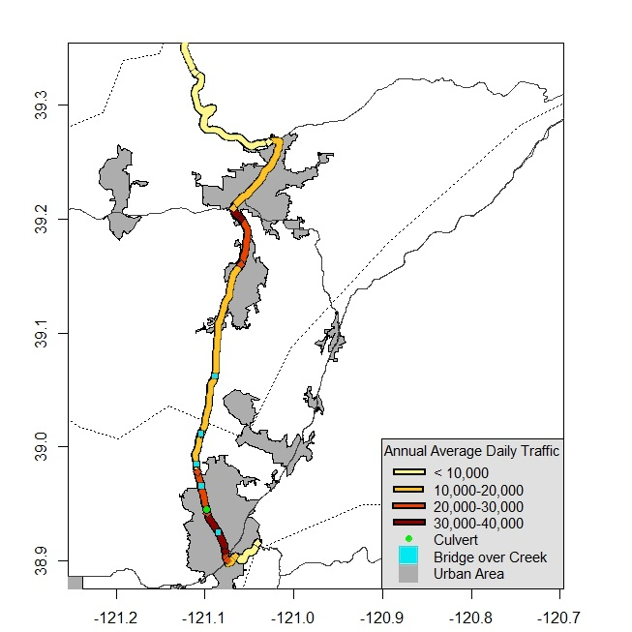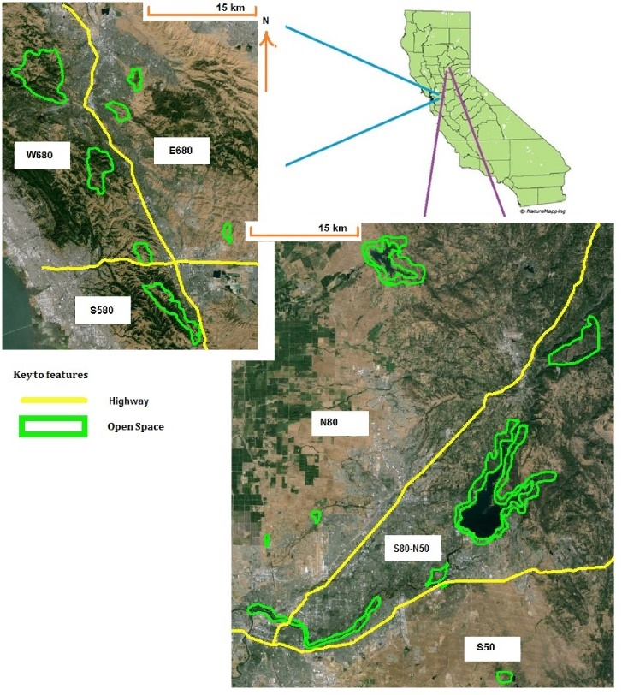Figure 1 - Map of study area and coyote sampling locations (in green). A) Bay Area sampling locations along I-580 and I-680. I-580 runs West-East, I-680 runs North-South. B) Sierra Nevada Foothill sampling locations along SR 50 and I-80. SR 50 runs West-East and I-80 runs Southwest-Northeast. Map of study area and Annual Average Daily Traffic (AADT) volumes along SR 49.

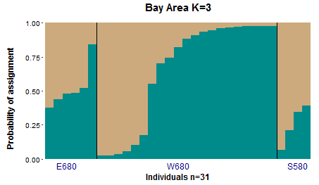Figure 2. Bar plot depicting individual assignments for coyotes sampled in the Bay Area. Each color corresponds to a genetic cluster identified by STRUCTURE, each bar corresponds to an individual sample, and the proportion of color in each bar depicts an individual’s proportional ancestry in each genetic cluster.

Figure 3. Bar plots depicting individual assignments for coyotes sampled in the study region. Each color corresponds to a genetic cluster identified by STRUCTURE, each bar corresponds to an individual sample, and the proportion of color in each bar depicts an individual’s proportional ancestry in each genetic cluster.

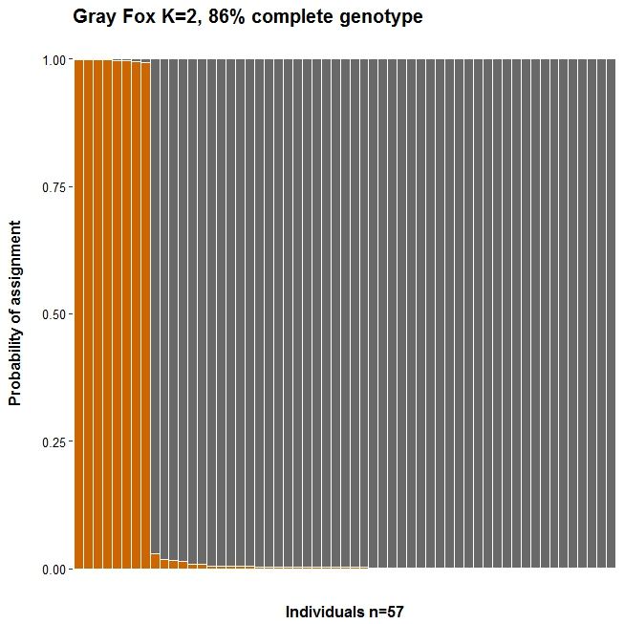Figure 4. Bar plots depicting individual assignments for gray fox sampled in the study region. Each color corresponds to a genetic cluster identified by STRUCTURE, each bar corresponds to an individual sample, and the proportion of color in each bar depicts an individual’s proportional ancestry in each genetic cluster.

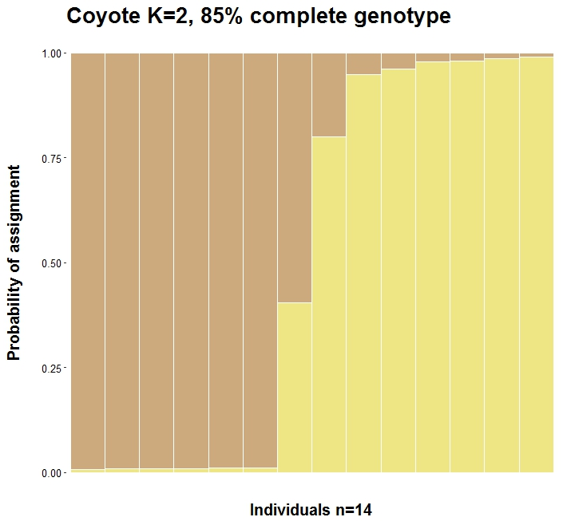

Figure 5. Map of sample collection locations of genotyped coyotes. Colors indicate the genetic cluster they assigned to during STRUCTURE analysis.

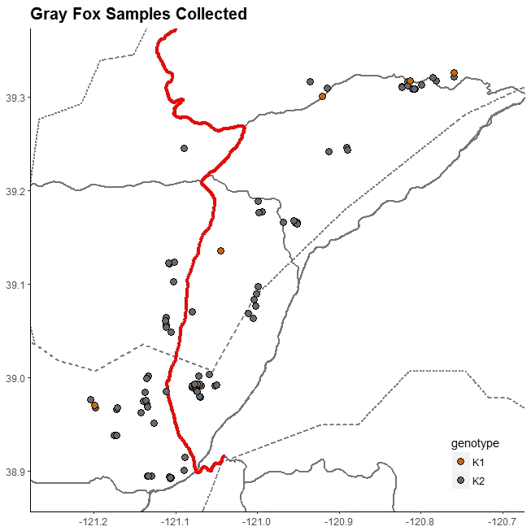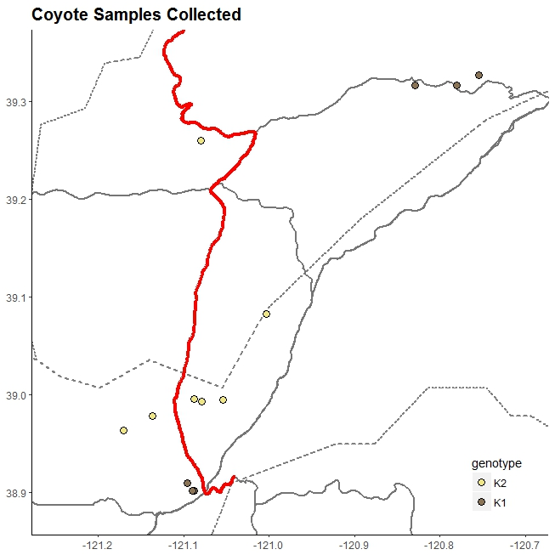Figure 6. Map of sample collection locations of genotyped gray foxes. Colors indicate the genetic cluster to which they assigned during STRUCTURE analysis.

Figure 2. Map of sample locations for related pairs. All samples from related pairs originated from the same side of the highway with the exception of one gray fox pair (pink circle), which was sampled across SR 49 approximately 9 km apart.

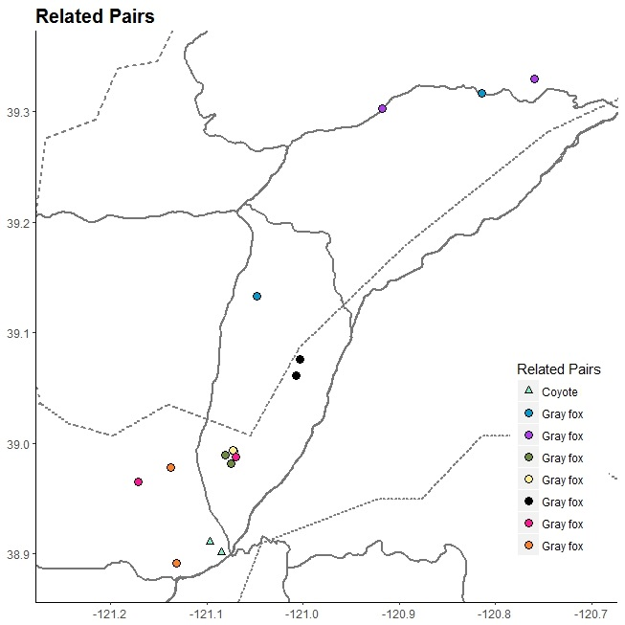

Alexander, S. M., N. M. Waters, and P. C. Paquet. 2005. Traffic volume and highway permeability for a mammalian community in the Canadian Rocky Mountains. Canadian Geographer 49:321–331.

Andrews, K. M., and J. W. Gibbons. 2016. How Do Highways Influence Snake Movement ? Behavioral Responses to Roads and Vehicles Published by : American Society of Ichthyologists and Herpetologists ( ASIH ) Stable URL : http://www.jstor.org/stable/4098651 REFERENCES Linked references are available 2005:772–782.

Atkinson, K. T., and D. M. Shackleton. 1991. Traffic Volumne and highway permeability for a mammaliam community in the Canadian Rocky Mountians. The Canadian Field-Naturalist 105:49–54.

Benítez-López, A., R. Alkemade, and P. A. Verweij. 2010. The impacts of roads and other infrastructure on mammal and bird populations: A meta-analysis. Biological Conservation 143:1307–1316.

Caltrans. 2015. 2015 Traffic Volumes on California State Highways.

Center for Strategic Econimic Research. 2014. Placer County Economic and Demographic Profile 2013.

Charry, B., and J. Jones. 2009. Traffic Volume as a Primary Road Characteristic Impacting Wildlife: A Tool for Land Use and Transportation Planning. Proceedings of the 2009 International Conference on Ecology and Transportation:159–205.

Clarke, R. T., P. Rothery, and A. F. Raybould. 2002. Confidence limits for regression relationships between distance matrices: Estimating gene flow with distance. Journal of Agricultural, Biological, and Environmental Statistics 7:361–372.

Clevenger, A. P., and N. Waltho. 2005. Performance indices to identify attributes of highway crossing structures facilitating movement of large mammals. Biological Conservation 121:453–464.

Coffin, A. W. 2007. From roadkill to road ecology: A review of the ecological effects of roads. Journal of Transport Geography 15:396–406.

Crooks, K. R. 2002. Relative Sensitivities of Mammalian Carnivores to Habitat Fragmentation. Conservation Biology 16:488–502.

Crooks, K. R., and M. E. Soulé. 1999. Mesopredator release and avifaunal extinctions in a fragmented system. Nature 400:563–566.

Delaney, K. S., S. P. D. Riley, and R. N. Fisher. 2010. A Rapid, Strong, and Convergent Genetic Response to Urban Habitat Fragmentation in Four Divergent and Widespread Vertebrates. PLoS ONE 5:e12767.

Deyoung, R. W., A. Zamorano, B. T. Mesenbrink, T. A. Campbell, B. R. Leland, G. M. Moore, R. L. Honeycutt, and J. J. Root. 2009. Landscape-Genetic Analysis of Population Structure in the Texas Gray Fox Oral Rabies Vaccination Zone. Journal of Wildlife Management 73:1292–1299.

Distance, G., P. Author, M. N. Source, C. Press, A. Society, and N. S. Url. 2016. Genetic Distance between Populations Author ( s ): Masatoshi Nei Source : The American Naturalist , Vol . 106 , No . 949 ( May - Jun ., 1972 ), pp . 283-292 Published by : University of Chicago Press for American Society of Naturalists Stable URL : http:/ 106:283–292.

Dixon, P. 2003. VEGAN, a package of R functions for community ecology. Journal of Vegetation Science 14:927–930.

Epps, C. W., and N. Keyghobadi. 2015. Landscape genetics in a changing world: Disentangling historical and contemporary influences and inferring change. Molecular Ecology 24:6021–6040.

Epps, C. W., P. J. Palsboll, J. D. Wehausen, G. K. Roderick, R. R. Ramey, and D. R. McCullough. 2005. Highways block gene flow and cause a rapid decline in genetic diversity of desert bighorn sheep. Ecology Letters 8:1029–1038.

Fahrig, L., and T. Rytwinski. 2009. Effects of roads on animal abundance: An empirical review and synthesis. Ecology and Society 14.

Faigin, D. P. 2020. Interstate Highway Types and the History of California’s Interstates. Available from: https://cahighways.org/itypes.html. https://cahighways.org/itypes.html.

Farias, V., T. K. Fuller, R. K. Wayne, and R. M. Sauvajot. 2005. Survival and cause-specific mortality of gray foxes (Urocyon cinereoargenteus) in southern California. Journal of Zoology 266:249–254.

Fedriani, J. M., T. K. Fuller, R. M. Sauvajot, and E. C. York. 2000. Competition and intraguild predation among three sympatric carnivores. Oecologia 125:258–270.

Frankham, R. 1996. Relationship of Genetic Variation to Population Size in Wildlife. Conservation Biology 10:1500–1508.

Galpern, P., M. Manseau, P. Hettinga, K. Smith, and P. Wilson. 2012. Allelematch: An R package for identifying unique multilocus genotypes where genotyping error and missing data may be present. Molecular Ecology Resources 12:771–778.

Grinder, M. I., and P. R. Krausman. 2001. Home range, habitat use, and nocturnal activity of coyotes in an urban environment. Journal of Wildlife Management 65:887–898.

Grubbs, S. E., and P. R. Krausman. 2009. Use of Urban Landscape by Coyotes. The Southwestern Naturalists 54:1–12.

Harrison, R. L. 1997. A Comparison of Gray Fox Ecology between Residential and Undeveloped Rural Landscapes. Journal of Wildlife Management 61:112–122.

Holderegger, R., and M. Di Giulio. 2010. The genetic effects of roads: A review of empirical evidence. Basic and Applied Ecology 11:522–531.

Hubisz, M. J., D. Falush, M. Stephens, and J. K. Pritchard. 2009. Inferring weak population structure with the assistance of sample group information. Molecular Ecology Resources 9:1322–1332.

Jaeger, J. A. G., J. Bowman, J. Brennan, L. Fahrig, D. Bert, J. Bouchard, N. Charbonneau, K. Frank, B. Gruber, and K. T. Von Toschanowitz. 2005. Predicting when animal populations are at risk from roads: An interactive model of road avoidance behavior. Ecological Modelling 185:329–348.

Kalinowski, S. T. 2005. HP-RARE 1.0: a computer program for performing rarefaction on measures of allelic richness. Molecular Ecology Notes 5:187–189.

Kopelman, N. M., J. Mayzel, M. Jakobsson, N. A. Rosenberg, and I. Mayrose. 2015. Clumpak: A program for identifying clustering modes and packaging population structure inferences across K. Molecular Ecology Resources 15:1179–1191.

Kowalski, B., F. Watson, C. Garza, and B. Delgado. 2015. Effects of landscape covariates on the distribution and detection probabilities of mammalian carnivores. Journal of Mammalogy 96:511–521.

Lande, R. 1988. Genetics and biological demography in conservation. Science 241:1455–1460.

Lombardi, J. V., C. E. Comer, D. G. Scognamillo, and W. C. Conway. 2017. Coyote, fox, and bobcat response to anthropogenic and natural landscape features in a small urban area. Urban Ecosystems 20:1239–1248.

Marsh, D. M., G. S. Milam, N. P. Gorham, and N. G. Beckman. 2005. Forest roads as partial barriers to terrestrial salamander movement. Conservation Biology 19:2004–2008.

McRae, B. H. 2006. Isolation By Resistance. Evolution 60:1551.

Moore, M., S. K. Brown, and B. N. Sacks. 2010. Thirty-one short red fox (Vulpes vulpes) microsatellite markers. Molecular Ecology Resources 10:404–408.

Nei, M. 1978. Estimation of average heterozygosity and genetic distance from a small number of individuals. Genetics 89:583–590.

Peakall, R., and P. E. Smouse. 2006. GenAlEx 6: Genetic analysis in Excel. Population genetic software for teaching and research. Molecular Ecology Notes 6:288–295.

Peakall, R., and P. E. Smouse. 2012. GenAlEx 6.5: genetic analysis in Excel. Population genetic software for teaching and research-an update. Bioinformatics 28:2537–2539.

Peterman, W. E. 2018. ResistanceGA: An R package for the optimization of resistance surfaces using genetic algorithms. Methods in Ecology and Evolution 9:1638–1647.

Peterman, W. E., G. M. Connette, R. D. Semlitsch, and L. S. Eggert. 2014. Ecological resistance surfaces predict fine-scale genetic differentiation in a terrestrial woodland salamander. Molecular Ecology 23:2402–2413.

Poessel, S. A., E. M. Gese, and J. K. Young. 2017. Environmental factors influencing the occurrence of coyotes and conflicts in urban areas. Landscape and Urban Planning 157:259–269.

Pritchard, J. K., M. Stephens, and P. Donnelly. 2000. Inference of Population Structure Using Multilocus Genotype Data. Genetics 155:945–959.

Rice, W. R. 1989. Analyzing Tables of Statistical Tests. Evolution 43:223–225.

RILEY, S. P. D. 2006. Spatial Ecology of Bobcats and Gray Foxes in Urban and Rural Zones of a National Park. Journal of Wildlife Management 70:1425–1435.

Riley, S. P. D., J. L. Brown, J. A. Sikich, C. M. Schoonmaker, and E. E. Boydston. 2014a. Wildlife Friendly Roads: The Impacts of Roads on Wildlife in Urban Areas and Potential Remedies. Pages 323–360 Urban Wildlife Conservation: Theory and Practice. Springer Science+Business Media.

Riley, S. P. D. P. D., L. E. K. E. K. Serieys, J. P. P. Pollinger, J. A. a Sikich, L. Dalbeck, R. K. K. Wayne, and H. B. B. Ernest. 2014b. Individual Behaviors Dominate the Dynamics of an Urban Mountain Lion Population Isolated by Roads. Current Biology 24:1989–1994.

Riley, S. P. D., J. P. Pollinger, R. M. Sauvajot, E. C. York, C. Bromley, T. K. Fuller, and R. K. Wayne. 2006. A southern California freeway is a physical and social barrier to gene flow in carnivores. Molecular Ecology 15:1733–1741.

Rountree, G. H. I. 2004. Comparative study of the home range and habitat usage of red foxes and gray foxes in an urban setting: a preliminary report. Pages 238–244 Proceedings 4th International Urban Wildlife Symposium.

Sacks, B. N., D. L. Bannasch, B. B. Chomel, and H. B. Ernest. 2008. Coyotes demonstrate how habitat specialization by individuals of a generalist species can diversify populations in a heterogeneous ecoregion. Molecular Biology and Evolution 25:1384–1394.

Sacks, B. N., B. R. Mitchell, C. L. Williams, and H. B. Ernest. 2005. Coyote movements and social structure along a cryptic population genetic subdivision. Molecular Ecology 14:1241–1249.

Sawaya, M. a, S. T. Kalinowski, and A. P. Clevenger. 2014. Genetic connectivity for two bear species at wildlife crossing structures in Banff National Park. Proceedings. Biological sciences / The Royal Society 281:20131705.

Van Strien, M. J., D. Keller, and R. Holderegger. 2012. A new analytical approach to landscape genetic modelling: Least-cost transect analysis and linear mixed models. Molecular Ecology 21:4010–4023.

Taylor, B. D., and R. L. Goldingay. 2010. Roads and wildlife: Impacts, mitigation and implications for wildlife management in Australia. Wildlife Research 37:320–331.

Temple, D. L., M. J. Chamberlain, and L. M. Conner. 2010. Spatial ecology, survival and cause-specific mortality of gray foxes (urocyon cinereoargenteus) in a longleaf pine ecosystem. American Midland Naturalist 163:413–422.

Toonen, R. J., and S. Hughes. 2001. Increased Throughput for Fragment Analysis on an ABI PRISM® 377 Automated Sequencer Using a Membrane Comb and STRand Software 31:1320–1324.

WAITS, L. P., and D. PAETKAU. 2005. Noninvasive Genetic Sampling Tools for Wildlife Biologists: a Review of Applications and Recommendations for Accurate Data Collection. Journal of Wildlife Management 69:1419–1433.

Wickham, H. 2016. ggplot2: Elegant Graphics for Data Analysis. Springer-Verlag New York. ISBN 978-3-319-24277-4, https://ggplot2.tidyverse.org.:98140.

Wright, L., and W. Wright. 2017. Effects of Interstate 95 on Breeding Birds in Northern Maine Author ( s ): Craig R . Ferris Source : The Journal of Wildlife Management , Vol . 43 , No . 2 ( Apr ., 1979 ), pp . 421-427 Published by : Wiley on behalf of the Wildlife Society Stable URL : h 43:421–427.